INTEGRATIVE COURSE IN PSYCHOLOGY (ICOPSYCH)

ANALYSIS ON THE RESULT OF POST-TEST EXAMINATION IN PSYCHOLOGICAL ASSESSMENT
MARCH 28, 2025

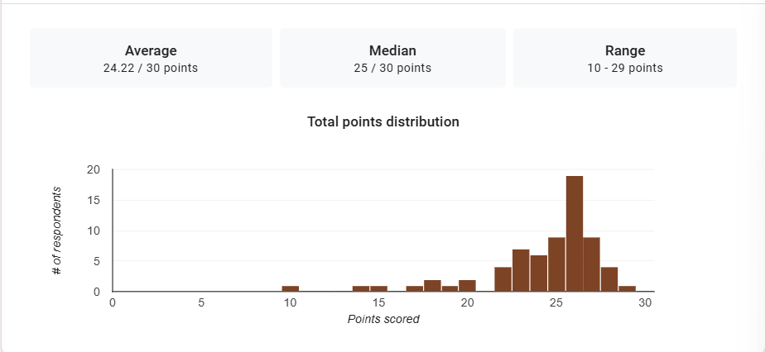

1. Mean Score: The mean score of 24.22 out of 30 indicates that, on average, the participants performed relatively well in the exam. This suggests that most individuals scored above the midpoint of the possible total score (15), but it also implies that there is some variation in the performance of participants.

2. Median Score: The median score of 25 out of 30 shows that the middle point of the scores is very close to the highest possible score. This means that half of the participants scored above 25, and half scored below. The fact that the median is slightly higher than the mean (24.22) suggests that the distribution of scores might be skewed slightly to the left (with more higher scores than lower ones).

3. Range: The range of 10 to 29 points indicates that there is a notable spread of scores. The lowest score is 10, while the highest score is 29. This shows that there is a variability in performance, but the majority of participants scored within a narrower band (likely closer to the median score of 25).

Interpretation Summary:

-The majority of participants performed well, with an average score of 24.22 out of 30.
-Most participants scored around the middle or higher range, with the median score being 25.
-The spread of scores shows that while there were some participants who scored much lower (a minimum of 10 points), the majority performed closer to the upper end of the scale, with 29 being the highest score.
-There may be a slight skew towards higher scores, as indicated by the median being higher than the mean. This suggests a relatively strong overall performance across the group.

RATIONALIZATION:

DIFFICULT QUESTIONS:

